Project Design Phase
Solution Architecture

Date | 01 July 2026
Team ID
Project Name | Customer Registry
Maximum Marks | 4 Marks

Solution Architecture:
Solution architecture is a complex process — with many sub-processes — that bridges the gap between business problems and technology solutions. Its goals are to:
- Find the best tech solution to solve existing business problems.
- Describe the structure, characteristics, behavior, and other aspects of the software to project stakeholders.
- Define features, development phases, and solution requirements.
- Provide specifications according to which the solution is defined, managed, and delivered.

Solution Architecture Diagram: Customer Registry
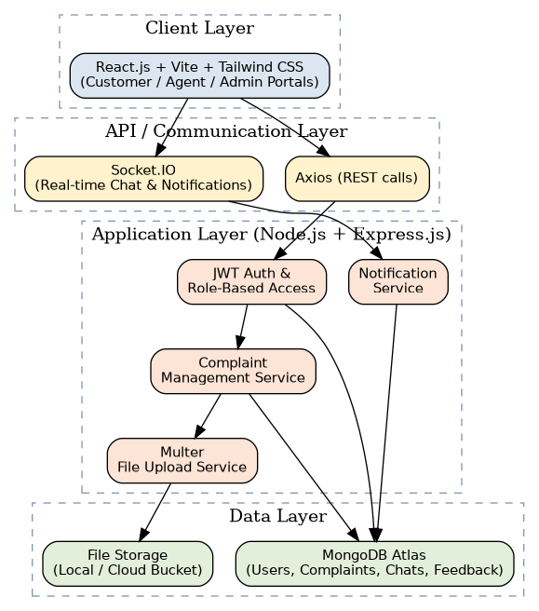
Figure 1: Layered architecture and data flow of the Customer Registry system

Layer Description
Layer | Technology | Responsibility
Client Layer | React.js + Vite + Tailwind CSS | Renders Customer, Agent, and Admin portals; consumes REST APIs via Axios and connects to Socket.IO for live chat/notifications.
API / Communication Layer | Axios, Socket.IO | Axios handles request/response REST communication; Socket.IO maintains persistent connections for real-time chat and notification delivery.
Application Layer | Node.js + Express.js | Hosts JWT authentication & role-based access, complaint management service, notification service, and Multer-based file upload service.
Data Layer | MongoDB Atlas | Stores Users, Complaints, Chat messages, and Feedback as documents; file attachments are stored via the upload service (local/cloud storage).

Key Architectural Decisions
- Stateless REST API secured with JWT allows the backend to scale horizontally across multiple instances.
- Socket.IO is layered alongside REST to support real-time chat and notifications without blocking the main request/response cycle.
- MongoDB's flexible document schema accommodates varying complaint attributes (category-specific fields, attachments) without frequent migrations.
- Role-based middleware in Express enforces that Customers, Agents, and Admins only access endpoints permitted for their role.

